What makes a good blog post?
- Purpose: What problem does it aim to solve?

- Catchy title: aim to catch the attention of your reader. Use a key word that captures your personality and stands you out.

- Great introduction: you have 2 seconds to arrest your reader’s attention, and get them to read your entire post.

- Summary: use bullet points to summarize your arguments. No one has the patience to read a long and boring blogpost.

- Mini-Content: ensure there is interesting content/value for your reader to take away.

- Use clear and unambiguous visual rhetoric to capture and captivate your audience.

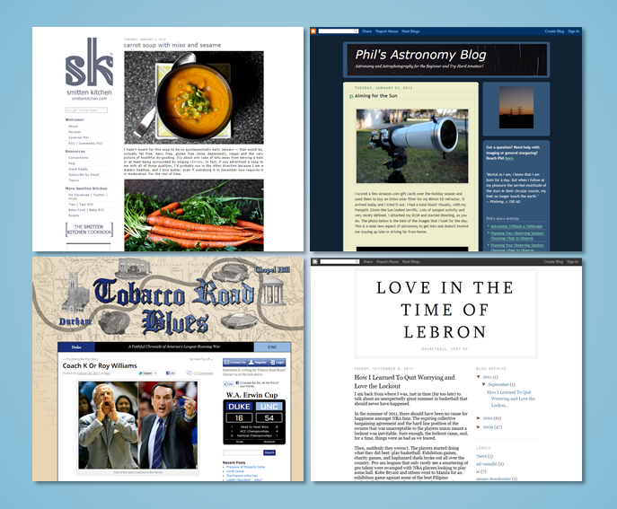

Examples of Blogs you might want to view.
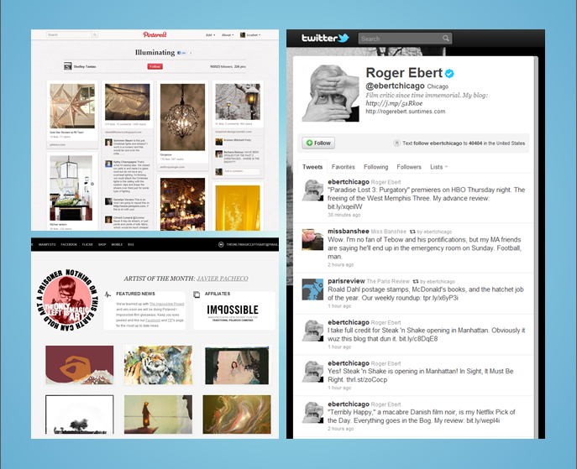

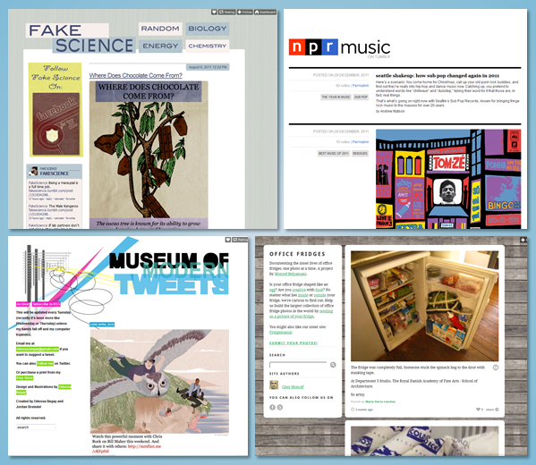
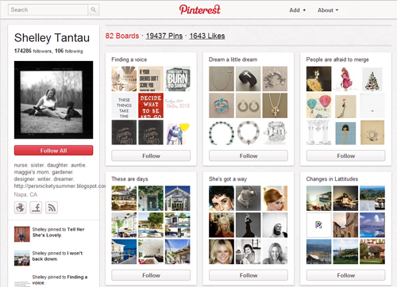

https://edu.gcfglobal.org/en/blogbasics/choosing-a-blog-service/1/

